**Report on Hospital Training-I**

**A report of training undergone at**

**FSD MULTI SPECIALITY HOSPITAL, JANKIPURAM, LUCKNOW**

**Submitted in Partial Fulfilment of B.Pharm 5th Semester**

**Subject- Hospital Training-I (BP-509P)**

**by**

**SARFRAJ ANSARI**

**(Roll no – 2109190500051)**

**Session 2023-24**



**Dr. A.P.J. ABDUL KALAM TECHNICAL UNIVERSITY, LUCKNOW**

**(Formerly Uttar Pradesh Technical University, Lucknow)**

**Under the supervision of**

**Prof. (Dr.) Ramesh Kumar Singh Mr. Shubham Yadav**

**BNCP, Lucknow. BNCP, Lucknow.**

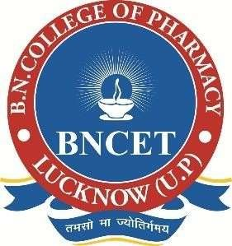

**to the**

**B. N. COLLEGE OF PHARMACY, LUCKNOW**

**(Affiliated to Dr. A.P.J Abdul Kalam Technical University, Lucknow)**

CERTIFICATE

This is to certify that **SARFRAJ ANSARI** has been successfully completed Hospital Training-I (BP-509P) for the partial fulfilment of B. Pharm 5th semester, as per the syllabus of Dr. A. P. J. ABDUL KALAM TECHNICAL UNIVERSITY, LUCKNOW in the academic year 2023-24.

Prof. (Dr.) Ramesh Kumar Singh Mr. Shubham Yadav

BNCP, Lucknow. BNCP, Lucknow.

DECLARATION

I hereby declare that the Hospital training was carried out by me in the certified

hospital **“FSD MULTI SPECIALITY HOSPITAL”** under the guidance of **“Dr. NITIN SINGH (M.B.B.S., M.S. General & Laparoscopic Surgeon)”.** Further, this work is not being submitted in part or in full to obtain any other degree/ diploma.

Place: LUCKNOW SARFRAJ ANSARI

Date: 02/12/2023 B.Pharm 3rd Year

Roll no - 2109190500051

BNCP, Lucknow.

# ACKNOWLEDGEMENT

I consider it as a great privilege and honor to have the opportunity to undergo the Hospital Training work in FSD MULTI SPECIALITY HOSPITAL, Jankipuram LUCKNOW. I have learned a lot during my training duration of 45 days. Hence, I would like to offer my heartiest thanks to Dr. NITIN SINGH (Doctor) for their guidance, supervision and providing regular information as well as about the hospital pharmacy Wish to place on record my since gratitude to the **Dr. Ramesh Singh** (Director of B.N. College of Pharmacy, Lucknow), **Mr. Virendra Singh** (Associate Professor Of Pharmaceutics at BNCP), **Shubham Yadav** (Assistant Professor) and entire faculty of the department. I thank them for their constructive help and encouragement throughout the project. Without their support and guidance taking this would not have been possible. I consider myself as a very lucky individuals as I provided with an opportunity to be a part of it. I am also grateful for having a chance to meet so many wonderful people and professional who led me though this training period.

**CONTENTS**

|  |  |  |
| --- | --- | --- |
| **S. No** | **Particulars** | **Page No.** |
| **1** | Objective of hospital training | 1 |
| **2** | About hospital | 2 |
| **3** | Wards in community health centre | 3 |
| **4** | Outpatient department (opd) | 4 |
| **5** | Prescription | 5 |
| **6** | Dispensing process | 6 |
| **7** | General ward | 7 |
| **8** | First aid treatment | 8 |
| **9** | 3 steps for emergency situations: | 9 |
| **10** | Emergency department | 10 |
| **11** | Pharmacy | 11 |
| **12** | Dressing | 12 |
| **13** | Injection room | 13-14 |
| **14** | Pathology | 15 |
| **15** | Ultrasound department | 16 |
| **16** | Conclusion | 17 |
| **17** | Work profile | 18 |
| **18** | References | 19 |

**OBJECTIVE OF HOSPITAL TRAINING**

* To promote awareness of health care among all sections of the Indian people
* To promote awareness among functionaries involved in Health and Hospital management.
* To promote the development of high-quality hospital services and community health care.
* To update the knowledge and skill of the Health and Hospital Administration and other personnel involved in the management of health care organization through continuous education and research.
* To promote research in the field of Health and the Hospital Management in order to improve the efficiency of Health Care Delivery System.
* To provide opportunities for training and research in all aspects of Hospital Services Health Care Delivery System and Health Care Administration.
* To promote a forum for the exchange of ideas and information among health and hospital planners, academicians, administrators, various stationary bodies and the general public for the improvement of Hospital and Health Care Delivery Systems
* To promote and grant recognition to research in the fields of Health and Hospital
* Management and to grant awards, scholarship and assistance in other suitable forms to meritorious individuals and institutions.
* To provide Health Care Advocacy for the benefits of health system management and to endeavor to become a national advisory body for union and state government.

**ABOUT HOSPITAL**

Hospitals are centre of treatment people from all comers of the society and all walks of life converge here to cure them shelf of their disease. A hospital is a health care institution providing patient treatment with specialized health science and auxiliary healthcare staff and medical equipment. The best-known type of hospital is the general hospital, which typically has an emergency department to treat urgent health problems ranging from fire and accident victims to a sudden illness. A district hospital typically is the major health care facility in its region, with many beds for intensive care and additional beds for patients who need long-term care Specialized hospitals include trauma centres, rehabilitation hospitals, children's hospitals, seniors' (geriatric) hospitals, and hospitals for dealing with specific medical needs such as psychiatric treatment (see psychiatric hospital) and certain disease categories. Specialized hospitals can help reduce health care costs compared to general hospitals.

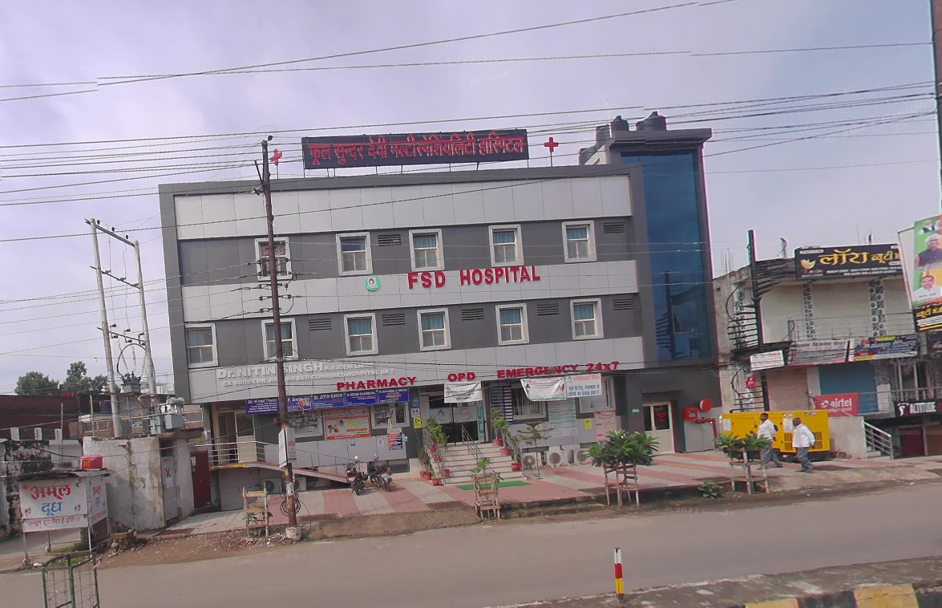I did my training in **FSD MULTI SPECIALITY HOSPITAL, JANKIPURAM, LUCKNOW.**

**Fig.No.1 FSD MULTI SPECIALITY HOSPITAL**

**WARDS IN COMMUNITY HEALTH CENTRE**

* OPD (Outer Patient Department)
* General Wards
* Emergency Wards
* Operation Theatre
* Pharmacy
* Injection Room
* Ultrasound Department
* X-Ray Department
* ECG Department
* Dressing Department

**OUTPATIENT DEPARTMENT (OPD)**

The outpatient department (OPD) plays a crucial role in the healthcare system by offering specialized care and treatment to individuals who do not require overnight stays at the hospital. Typically situated on the ground floor for easy accessibility, the OPD is strategically organized to enhance the overall efficiency of the medical facility. In addition to consultation services, the department is equipped with essential amenities such as wheelchairs and stretchers to cater to non-ambulatory patients. Adjacent to the main waiting area, patients and their families can access a variety of facilities, including conveniently located toilets, public telephones, a canteen for refreshments, and a water dispenser for hydration.

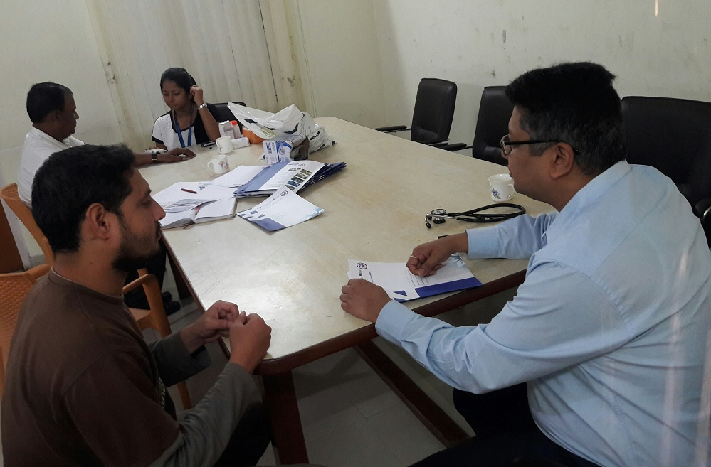 The seamless operation of the outpatient department relies on the proximity of essential services like X-ray facilities, laboratories, the medical record office, and a well-stocked pharmacy. These integral components contribute to a comprehensive and patient-centered approach to healthcare delivery. Notably, the FSD Multi Speciality Hospital distinguishes itself by maintaining a dedicated outpatient department with operational hours from 08:00 AM to 2:00 PM, ensuring that individuals receive timely and specialized medical attention. This commitment to a separate outpatient facility underscores the hospital's dedication to providing high-quality, accessible healthcare services to the community.

**Fig.No.2 OPD**

**PRESCRIPTION**

Prescription is defined as a written or in any other form document issued by a Registered Medical Practitioner or any other licensed practitioners. Prescription is a way of communication between physician and pharmacist in which physician and other healthcare professionals authorized pharmacist to dispense or compound a specific prescription drug for a specific patient or caretaker. It is often abbreviated ℞ or Rx.

Under Drug and Cosmetic Act, 1945, A Prescription should have following particulars:

“For the purposes of clause (9) a prescription shall

(a) be in writing and be signed by the person giving it with his usual signature and be dated by him;

(b) specify the name and address of the person for whose treatment it is given, or the name and address of the owner of the animal if the drug is meant for veterinary use;

(c) indicate the total amount of the medicine to be supplied and the dose to be taken.”

**Contents of the Prescription :**

* Prescribers office information: Name, qualification, address & Regn. No.
* Patient information: Name & address, Age, Sex, Ref. No.
* Date
* Rx Symbol (Known as Superscription Part)
* Medication Prescribed (Known as Inscription Part)
* Dispensing directions to Pharmacist (Known as Subscription Part)
* Directions for patient to be placed on label
* Refill, Special labeling and /or other instructions
* Prescriber’s signature and license (or) Drug Enforcement Agency (DEA) number as required.

**DISPENSING PROCESS**

Training Imparted

The consistent, repeated use of good dispensing procedures is vital in ensuring that errors are detected and corrected at all stages of the dispensing process. The term dispensing process covers all activities involved, from receiving the prescription to issuing the prescribed medicine to the patient.

The development and use of written standard operating procedures (SOPs) for the dispensing process will improve consistency and quality of work and can be used for training and reference. The framework for such SOPs may be based on the six major areas of activity:

1. Receive and validate the prescription

2. Understand and interpret the prescription

3. Prepare and label items for issue

4. Make a final check

5. Record the action taken

6. Issue medicine to the patient with clear instructions

and advice

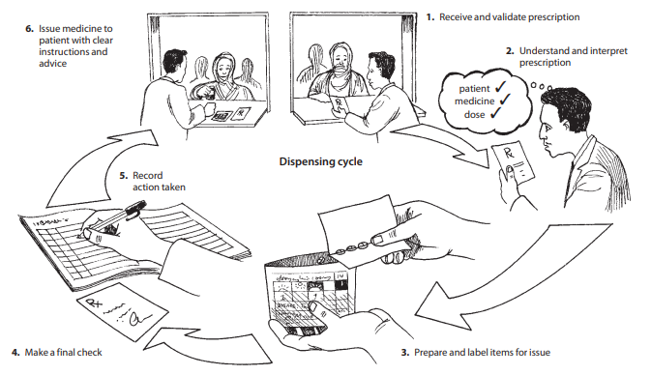

**Fig. No. 3 Dispensing Process**

**GENERAL WARD**

* A general ward is a large room where people who need medical treatment stay in general wards
* General wards have a cubicle room having six to eight patient bed and toilet in the wings of the ward.
* These wards are fully-equipped nursing station, Attendant couch. Qualified dietitian for diet advice and diet service.
* In general ward, those patients are only stay who is not suffered from any chronic disease.

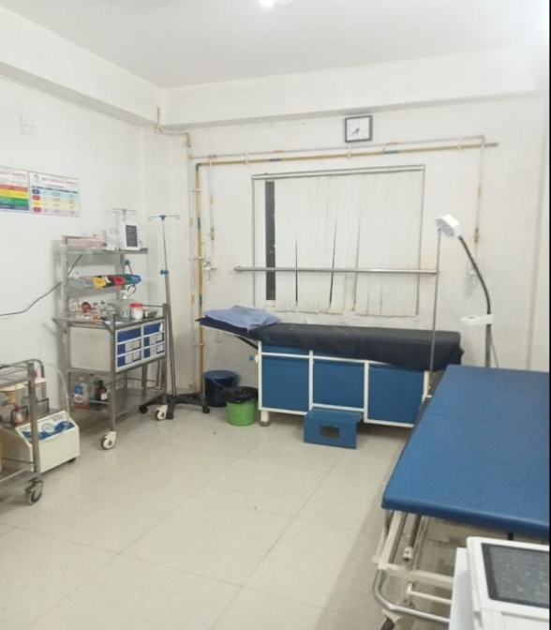

**Fig.No.4 GENERAL WARD**

**FIRST AID TREATMENT**

When you provide basic medical care to someone experiencing a sudden injury or illness, it's known as first aid.

In some cases, first aid consists of the initial support provided to someone in the middle of a medical emergency. This support might help them survive until professional help arrives.

In other cases, first aid consists of the care provided to someone with a minor injury. For example, first aid is often all that's needed to treat minor burns, cuts, and insect stings

**FIRST AID**

The primary goal of first aid is to prevent death or serious injury from worsening. The key aims of first aid are-

* Preserving life
* Preventing injury or illness from getting worse
* Relieving pain
* Aiding recovery
* Protecting the unconscious

The primary aim is to of course save lives. These main aims are so important in doing that, if they are properly implemented.

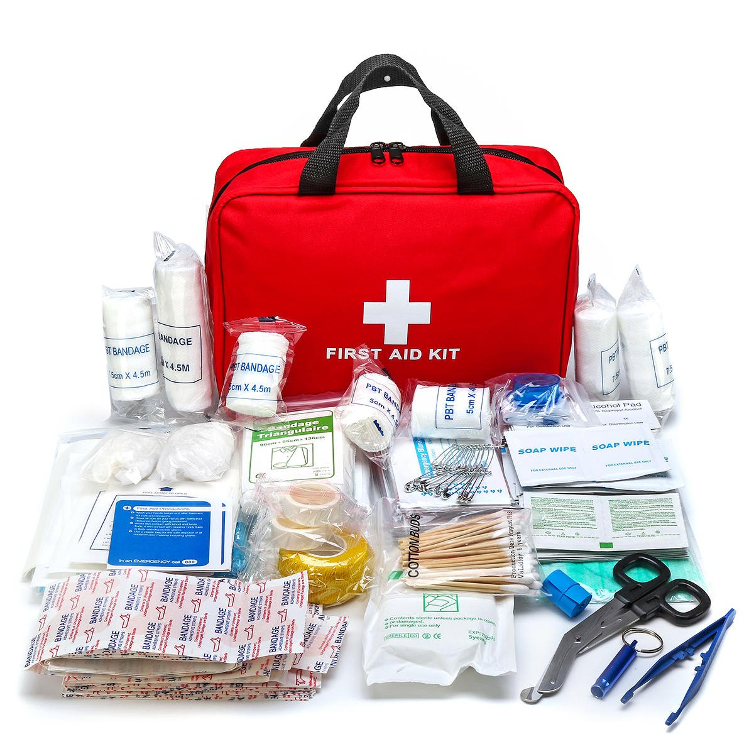

**Fig.No.5 FIRST AID KIT**

**3 STEPS FOR EMERGENCY SITUATIONS:**

If you encounter an emergency situation, follow these three basic stops

**1. Check the scene for danger**

Look for anything that might be dangerous, like signs of fire, falling debris, ur violent people. If your safety is at risk, remove yourself from the area and call for help. If the scene is safe, assess the condition of the sick or injured person. Don't move them unless you must do so to protect them from danger

**2. Call for medical help, if needed**

If you suspect the sick or injured person needs emergency medical care, tell a nearby person to call 911 or the local number for emergency medical services. If you're alone, make the call yourself

**3. Provide care**

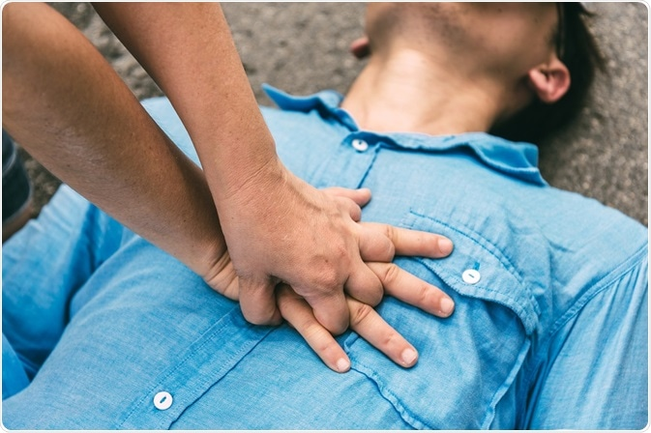If you can do so safely, remain with the sick or injured person until professional help arrives. Cover them with a warm blanket, comfort them, and try to keep them calm. If you have basic first aid skills, try to treat any potentially life-threatening injuries they have. Remove yourself from danger if at any point in the situation you think your safety might be at risk.

**Fig.No.6 CPR**

**EMERGENCY DEPARTMENT**

The emergency department (ED) is a pivotal component of the healthcare system, serving as the frontline for patients in need of immediate and critical care. Its significance lies in the timely provision of clinical interventions that can be life-saving. The ED is responsible for receiving, sorting, and prioritizing patients based on the urgency and complexity of their conditions. The spectrum of cases ranges from major trauma and stroke to intoxication and mental disorders, rendering the ED a multifaceted and complex healthcare environment.

The complexity of the ED is further heightened by the potential consequences of improper facility design. One major challenge is crowding, a pervasive issue with far-reaching implications. Crowding is associated with increased patient mortality, diminished quality of care, prolonged waiting times, higher rates of patients leaving without being seen, and extended length of stay. These consequences underscore the critical need for thoughtful and efficient facility design in emergency healthcare settings.

Addressing facility design in the ED is crucial for optimizing patient outcomes and overall system efficiency. A well-designed ED can mitigate the challenges posed by the diverse and unpredictable nature of emergencies, ensuring that healthcare professionals can deliver timely and high-quality care to those in urgent need. As such, the design and management of the ED must be approached with careful consideration of the unique demands it faces in order to provide optimal emergency healthcare services.

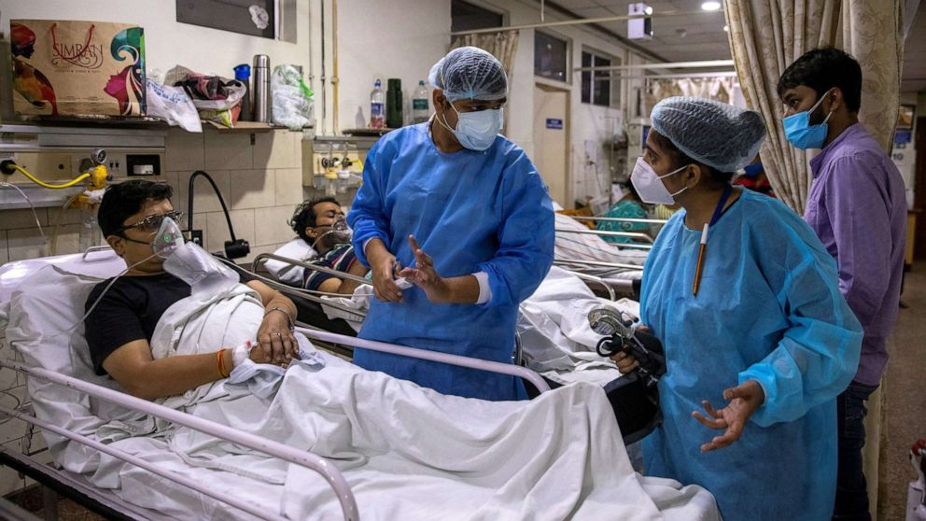

**Fig.No.7 EMERGENCY DEPARTMENT**

**PHARMACY**

The drug distribution room is a vital department within a hospital, dedicated to the preparation, compounding, stocking, and dispensing of inpatient medications. Unlike community settings, drug distribution rooms stock a diverse range of medications, including specialized and investigational drugs. This comprehensive inventory caters to the complex healthcare needs of hospitalized patients. The department also extends its services beyond inpatients by dispensing both over-the-counter and prescription medications to outpatients.

In fulfilling its role, the drug distribution room manages substantial quantities of medications daily, strategically allocating them to various wards and intensive care units based on individual patient medication schedules. To enhance efficiency, larger hospitals often deploy automated transport systems for the seamless distribution of medications.

The array of medications available in the drug distribution room serves a crucial role in treating diverse medical conditions, thereby contributing to the well-being of patients, including those with limited financial means. As a nexus for medication management within the hospital, the drug distribution room plays a pivotal role in ensuring timely and accurate access to pharmaceutical interventions, fostering optimal patient care.

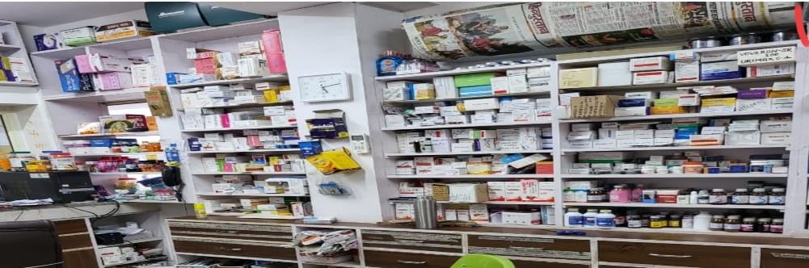

**Fig.No.8 PHARMACY**

**DRESSING**

A dressing or compress serves as a fundamental component in the realm of wound care, acting as a sterile pad meticulously applied to wounds with the dual purpose of fostering healing and shielding against further harm. It stands apart from a bandage, which primarily functions to secure the dressing; in the modern era, many dressings offer the added convenience of being self-adhesive, streamlining the application process. Cuts and wounds, typical sources of bleeding, vary in severity, with potential implications of internal bleeding in more severe cases. Notably, not all instances of bleeding necessitate immediate medical attention; adept first aid practices at home can often effectively manage such incidents.

However, when confronted with substantial blood loss, individuals may manifest symptoms such as feeling unwell, exhibiting pallor, experiencing dizziness, and, in severe instances, losing consciousness. Recognition of these indicators is critical, signaling the imperative need for urgent medical attention. Timely intervention becomes paramount to avert complications and ensure the well-being of the injured person. The role of dressings transcends mere physical protection, encompassing a broader context of facilitating healing, managing bleeding, and contributing significantly to the overall success of first aid measures and subsequent medical care. Understanding the multifaceted functions and implications of dressings is pivotal in navigating the spectrum of wound management and emergency response with efficiency and efficacy.

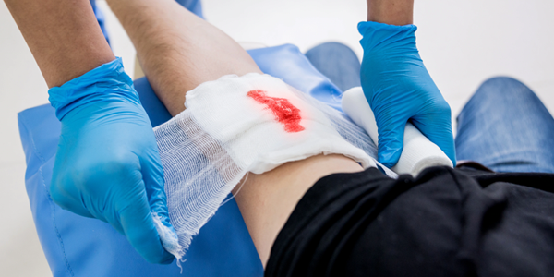

**Fig.No.9 DRESSING**

**INJECTION ROOM**

* Injection is a technique for delivering drugs parenteral administration. Mala administration via a route other than through the digestive tract.
* Parenteral injection includes subcutaneous, intramuscular, intravenous.
* intraperitoneal, intracardiac, intraarticular and extracavernous injection.
* Injection is generally administered as a bolus, but can possibly be used but continuous drug administration as well.
  + - **Various Method of injection**

**Intramuscular injection**

* Intramuscular injections deliver substances deep into muscles for rapid absorption through blood vessels. Administered at a 90-degree angle, common injection sites include the deltoid, vastus lateralis, and ventrogluteal muscles. This method is often employed for inactivated vaccines like influenza. While medical professionals are trained for intramuscular injections, patients can also receive training to self-administer medications, such as epinephrine, enhancing their ability to manage certain medical conditions independently. This approach facilitates timely and targeted delivery of medications, ensuring efficient absorption and therapeutic effectiveness.

**Subcutaneous injection**

* Subcutaneous injections deliver medication to the tissue between the skin and muscle, employing a 45-degree angle for administration. Unlike intramuscular injections, absorption is slower. The use of a larger gauge and short needle is common as the injection doesn't penetrate deep muscles. The typical administration site is the fat tissue behind the arm. Subcutaneous injections are notably employed for insulin administration and certain vaccines like MMR (Measles, Mumps, Rubella), Varicella (Chickenpox), and Zoster (Shingles). This method facilitates controlled and gradual absorption, making it suitable for medications requiring a more extended release into the bloodstream.

**Intravenous injection**

* Intravenous injections involve the direct insertion of a needle into a vein, delivering substances directly into the bloodstream at a 25-degree angle. Renowned for its speed, this method is the fastest way to achieve the desired therapeutic effect in medicine and drug administration. By bypassing other routes, the medication swiftly enters the bloodstream, ensuring rapid distribution throughout the entire body. The immediacy of intravenous delivery makes it a preferred choice in situations where a quick and efficient response is crucial, allowing for prompt and precise management of medical conditions and emergencies.

**Intradermal injection**

* Dermal injections involve delivering medication directly into the dermis, just below the skin's epidermis. Administered at a 5 to 15-degree angle with the needle almost flat against the skin, this method has a more prolonged absorption duration compared to other parenteral routes. It finds common use in sensitivity tests like tuberculin and allergy tests, as well as local anesthesia tests. The forearm and lower back are typical sites for dermal injections. Although absorption is slower, this method is valuable for specific diagnostic and therapeutic purposes where a controlled and localized response is desired.

**Intra arterial route**

* Intra-arterial injection is employed for chemotherapy in malignant tumors and in angiography, providing targeted and precise delivery of therapeutic agents for enhanced treatment effectiveness or diagnostic imaging in specific medical contexts.

**Intra cardiac route**

* Injection can be applied to the left ventricle in case of cardiac arrest.

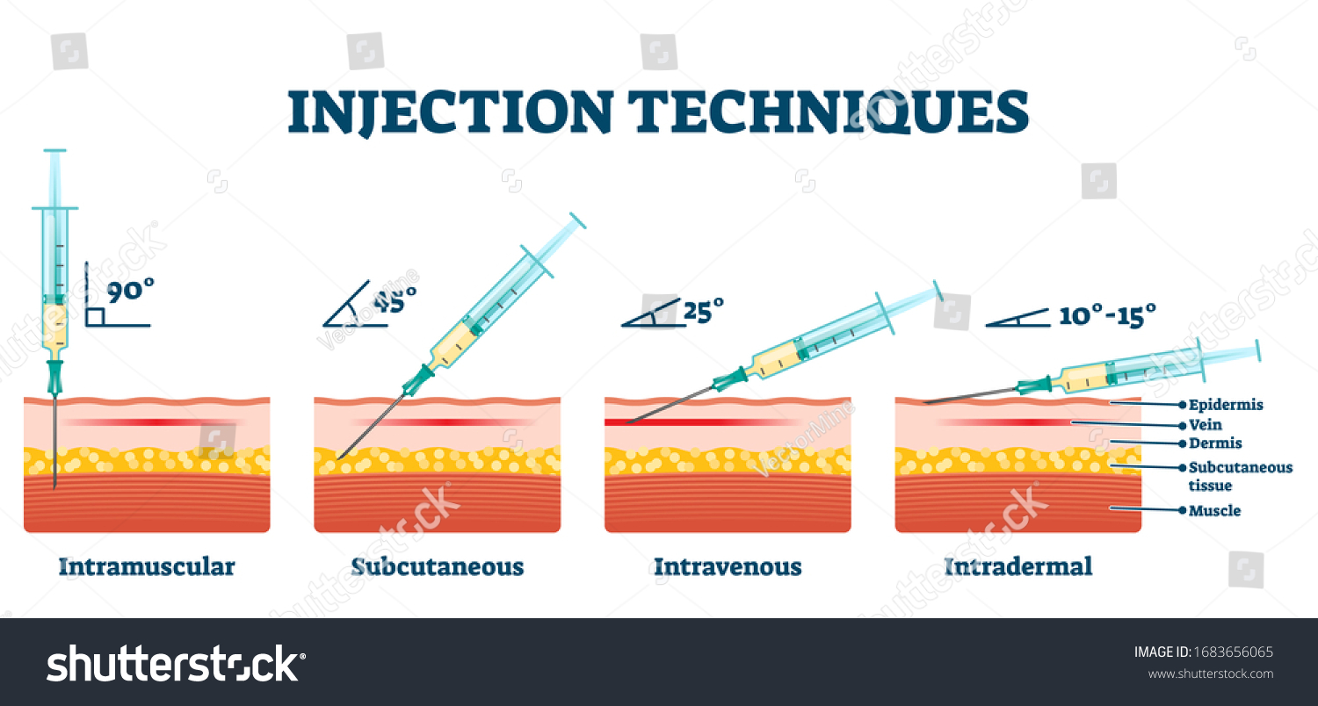

**Fig.No.10 INJECTION TECHNIQUE**

**PATHOLOGY**

Clinical pathology, a cornerstone of laboratory medicine, involves the meticulous analysis of blood, urine, and tissue samples to unravel and diagnose a spectrum of diseases. Laboratories specializing in clinical pathology provide indispensable information, encompassing blood count, clotting mechanisms, and electrolyte levels, crucial for medical professionals to comprehend and address various health conditions. Blood tests, a routine diagnostic procedure, are typically conducted by skilled nurses or technicians in laboratories or medical offices. The process, taking only a few minutes, involves a preliminary cleaning of the arm area before drawing blood, ensuring a swift and accurate collection of samples.

In a broader context, pathology emerges as the systematic study of diseases, serving as an indispensable bridge linking scientific knowledge with medical applications. Pathology's far-reaching influence extends across patient care, influencing diagnostic practices, guiding treatment decisions, incorporating advanced genetic technologies, and contributing to disease prevention strategies. Pathology's insights play a pivotal role in comprehending disease nature, empowering healthcare professionals with the knowledge needed to make informed decisions and deliver effective care. As technological advancements unfold, pathology evolves, constantly shaping and advancing medical knowledge, thereby enhancing the quality and precision of healthcare practices.

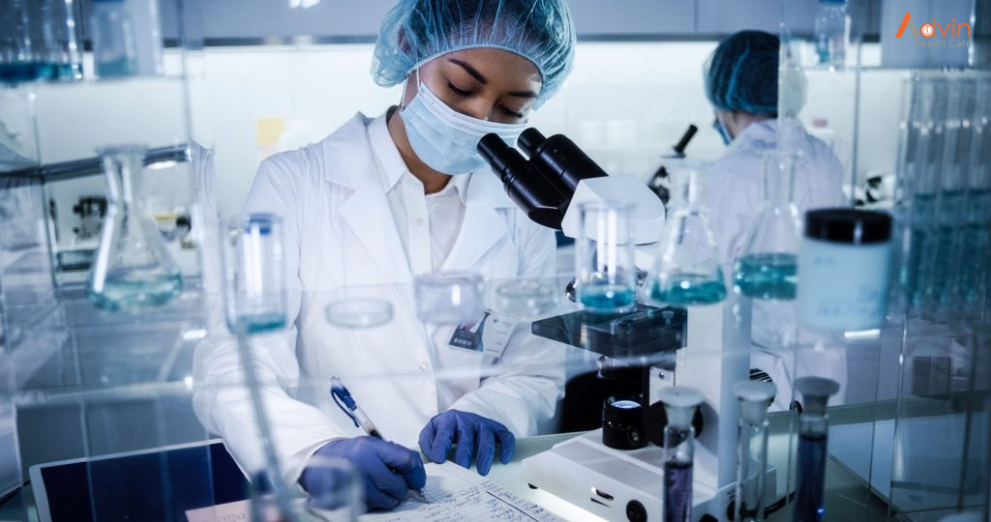

**Fig.No.11 PATHOLOGY DEPARTMENT**

**ULTRASOUND DEPARTMENT**

* Ultrasound (also called sonography or ultrasonography) is a noninvasive imaging test. An ultrasound picture is called a sonogram. Ultrasound uses high-frequency sound waves to create real-time pictures or video of internal organs or other soft tissues, such as blood vessels.
* Ultrasound scans employ high-frequency sound waves to create detailed images of internal body structures without radiation. Doctors commonly use this non-invasive technique for diverse applications, including monitoring fetal development, studying abdominal organs, muscles, tendons, and assessing heart and blood vessels. Its real-time capabilities and safety make it a versatile and widely utilized diagnostic tool in medical practice.

**Benefits of Ultrasound**

* They are generally painless and do not require needles, injections, or incisions.
* Patients aren't exposed to ionizing radiation, making the procedure safer than diagnostic techniques such as X-rays and CT scans. ...
* Ultrasound captures images of soft tissues that don't show up well on X-rays.

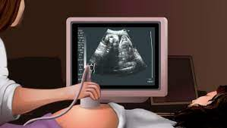

**Fig.No.12 ULTRASOUND DEPARTMENT**

**CONCLUSION**

* During training procedures, I have got lot of knowledge about following
* Stated project a training regarding each and every first aid procedures. I include checking the symptoms and treating at small scale in first aids and later transferring for surgical procedures.
* I got known regarding artificial respiration process and wound dressing.
* Sites of injection which includes knowledge of syringes, routes of injections Routes of injections such as I.V., LM, ID., Subcutaneous etc.
* In Prescription reading, its parts and the abbreviations used are studied by me in this project it's truly a scandalous matter for pharmacist’s study.
* Later the dispensing procedure is stated therefore which was practiced by me all around the training at regular intervals.
* I also learn about patient observation chart and how to fill it, use it.
* In Simple diagnostic reports that are easy to study in case of pathological reports but a bit of difficulty arises in reading radiological reports.
* Therefore I have got a marvelous experience by this training.

**WORK PROFILE**

* During 45 days of hospital training-II. I came to learn about how to dispensed medicines to the patient, how to inject injection to them, how to manage emergency cases. I also learn about dealing with hospital conditions like diseases of patient, wards, staff members, different departments etc.
* The staff and doctor are all host and good natured towards the patient and listen to their problems. Each and every department has its own way of working. There is no carelessness towards the patients their drugs and injection and they are treated on time.

**REFERENCES**

* + Reynard, Jonathan. "Corpus Curricula: Medical Education and the Voluntary Hospital Movement". Retrieved 17 December 2012.
  + Roderick E. McGrew, Encyclopedia of Medical History (Macmillan 1985), page no. 139
  + Michael Marks Davis; Andrew Robert Warner (1918). Dispensaries, Their Management and Development: A Book for Administrators, Public Health Workers, and All Interested in Better Medical Service for the People.
  + World Health Organization. (2018). Essential medicines and health products: Prescription writing.
  + Mehta, R. M. (2017). Pharmaceutics-1 (4th ed.). Vallabh Prakashan.
  + Reynard, J. (Year). "Corpus Curricula: Medical Education and the Voluntary Hospital Movement." [Title of the Journal/Book].
  + American Heart Association. (2022). CPR & First Aid.
  + National Health Service. (2022). First Aid - Burns.
  + Emergency Nurses Association. (2022). Guidelines for Emergency Department Design.
  + World Health Organization. (2022). Injection safety.
  + National Center for Biotechnology Information. (2022). Principles of Drug Dispensing.
  + World Health Organization. (2022). Clinical Pathology.
  + National Health Portal India. (2022). Emergency Medical Services.
  + National Health Mission. (2022). Operational Guidelines for Emergency Medical Services.
  + Government of India. (2022). Drugs and Cosmetics Act, 1940.